“STUDENT NAME”
“UNIVERSITY OF AFFILIATION”

KENYA’S ECONOMIC TRADE PROFILE ESSAY

Introduction

Kenya is a Country situated in Africa bordered by Uganda,Tanzania,Somalia and Ethiopia.Due to this the country is considered as a hub to commercial, economic and logistics in the region. (Export.gov, 2019). Kenya has been a hive for investors and investing countries whom swarm to the region to take advantage of its economic and regional merits especially its very own strategic locality, entrepreneurial culture and its regional financial hub setup.
Kenya’s capital is Nairobi, and is the largest in the region and its rated to be between Cairo and Johannesburg. Mombasa is another major city along the coast of the country with one of the biggest ports in the region satisfying the needs of many countries in the region that are landlocked like Uganda, Rwanda and Burundi..

Kenya being largely a young populous country of about 79% and a national population of 47.2 Million as at 2016 (Export.gov, 2019); this makes the country to have a large disposable human resource that is well versed with entrepreneurship and multilingual culture embedded deep.
Agriculture is the main source of income in Kenya and the main drive force to economic growth. According to (Export.gov, 2019), it accounts for more than 35% of the GDP and is also 70% of the economy is employed or directly influenced by the sector.

Therefore, to understand further Kenyas’ economic trade profile we must discuss the main exports and imports of the nation.

Key Exports
The main exporters from Kenya being to; Pakistan8.64%, Russia 6.56% ,United Kingdom 5.28%, USA 6.56%,UAE 4.06%.
In 2013 Kenya was ranked as position 103 in total exports in the world economyThe key exports of Kenya as per (Commonwealth Network,2020).
- Tea :-
- Coffee
- Floriculture
- Cement
- Aquaculture (fish)
- Horticulture
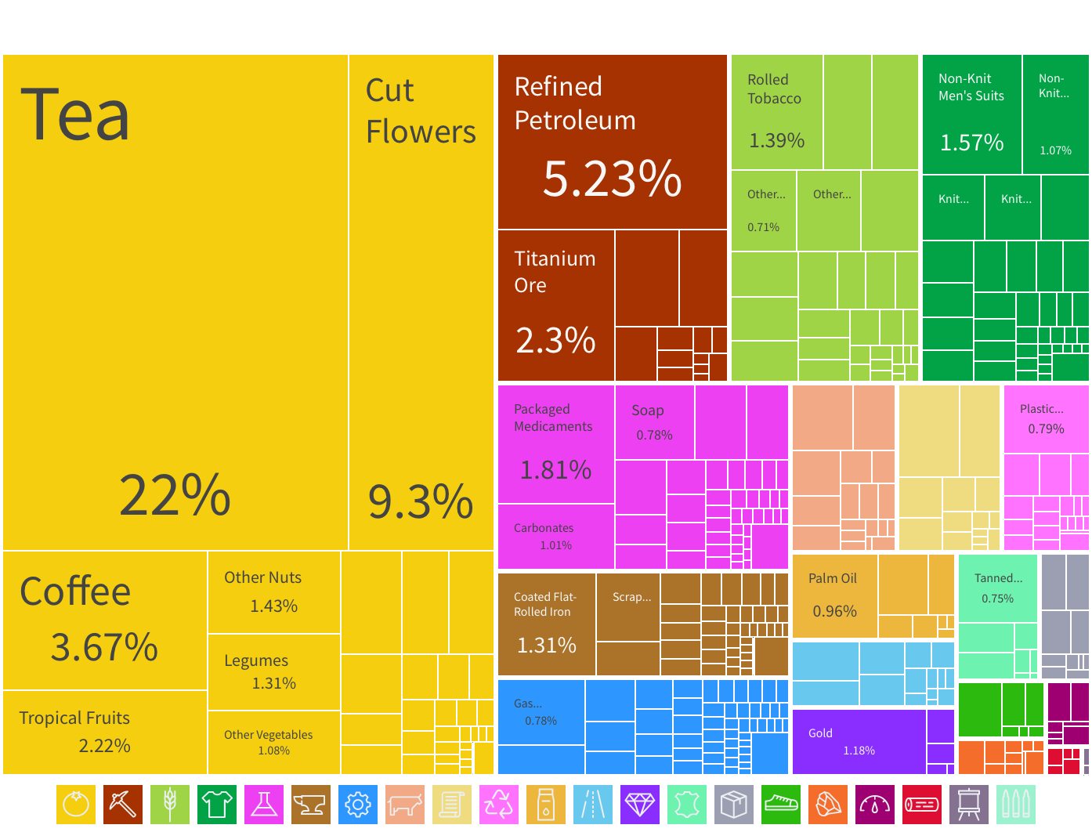
Below is figure 1, with a graphical visualization representing the key exports in percentages,
Fig 1:- https://oec.world/en/visualize/tree_map/hs92/export/ken/all/show/2018/

Key Imports
Big importers to Kenya as at 2018, being; China 21.1%,India 9.96% , Saudi Arabia 8.86%, UAE 8.68%, Japan 5.34%, United Kingdom 2.52%.
The net imports in Kenya as at 2005 accounted for almost 8% of the GDP, and it’s the biggest importer of oil (Commonwealth Network, 2020). They include;
- Oil
- Petroleum products
- Machinery and transportation equipment
- Motor vehicles
- Minerals (Iron and Steel)
- Plastics

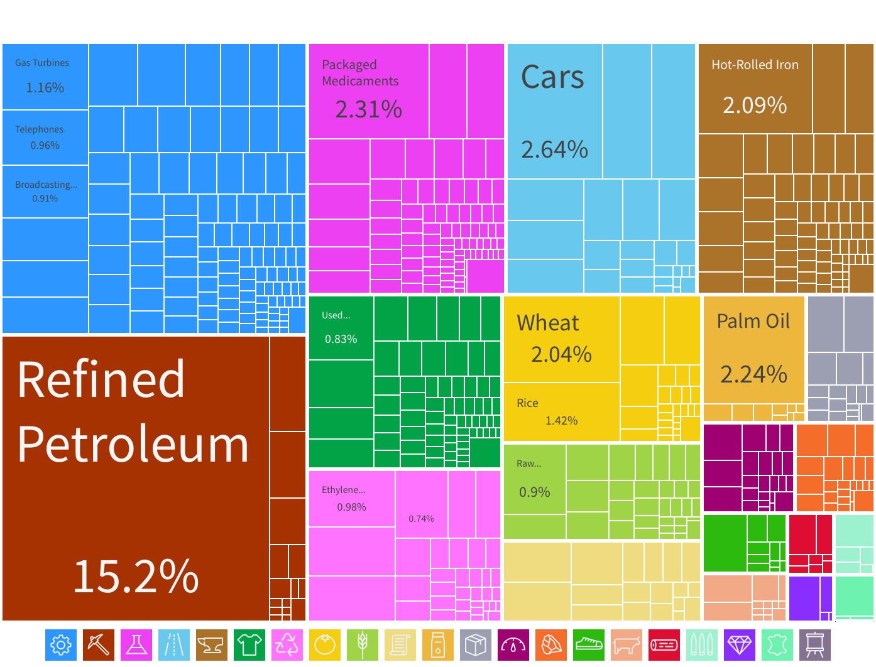
The figure 2 below is a graphical visualization representing the key imports in volumes as percentages,
Fig 2:- https://oec.world/en/visualize/tree_map/hs92/import/ken/all/show/2018/

Conclusion
It is in this respect that we find Kenya follows the Ricardian model of comparative advantage theory; which states that a country specializes in producing what they produce best at a lower cost in comparison to other countries, or have in abundance and trade for what a fore country can produce cheaply.Therefore both countries will benefit by gaining goods that could be expensively produced internally for cheaper alternatives,(Saylor Academy,2012).
In this case the exports of Kenya are cheaply aquired by foreign countries from Kenya and the vice versa applies for imports Kenya gets from foreign countries.

References

Export.gov. Retrieved from www.export.gov website
https://www.export.gov/article?series=a0pt0000000PAuAAAW&type=Country_Commercial__kav

Commonwealth Network,2020. Retrieved from www.commonwealthofnations.org website:
https://www.commonwealthofnations.org/sectors-kenya/business/import_and_export/

OEC.World, Retrieved from;
https://oec.world/en/profile/country/ken

Saylor Academy,2012. International trade theory and Policy. Retrieved from saylordotorg website:
https://saylordotorg.github.io/text_international-trade-theory-and-policy/s05-the-ricardian-theory-of-compar.html

